A

Project Report

on

***“Uni-Connect”***

Submitted in partial fulfillment of the requirements for the award of degree

**Master of Information Technology**

**Semester: IV**

*From*

Hemchand Yadav Vishwavidyalaya, Durg (C.G.)

Year : 2024-25

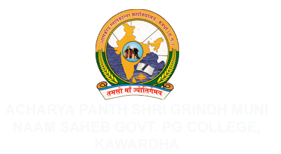

Submitted By –

Pankaj Kumar Baghel

Roll No.: 2440165012

**Internal Guide–**

**Dr. Anil Kumar Sharma**

**HOD Of (CS/IT) Department,**

**A.P.S.G.M.N.S. Govt. P.G. College, Kawardha (C.G.)**

**Project Guide :–**

**Mr. Abhijeet Kaushik**

**Dy. Director (IT),**

**National Informatics Center,**

**Nava Raipur (C.G)**

Submitted to

A.P.S.G.M.N.S. Govt. P.G. College, Kawardha (C.G.)

Affiliated to

Hemchand Yadav Vishwavidyalaya, Durg (C.G.)